

**Faculty of Business and Information Technology**

**Bachelor of Information Technology**

**IT5x82: Fundamentals of Data Models and Databases**

21600681

Christopher Simmons

**Contents Page**

**Page 3 - Summary**

**Page 4 - Assumptions**

**Page 5 - business process models**

**Page**

**Page**

**Page**

**Page**

**Page**

**Page**

**executive summary**

Thomas Cook Travels is a business that helps people plan their vacation. Thomas Cook Travels promotes resorts and matches customers with the resorts. Currently, Thomas Cook Travels performs its booking service on paper but it would like to automate these processes.

The purpose of this assignment is to document the requirements for a database system using models created in Visio and Visual Paradigm.

Can it be done?

Yes!!!

**list of assumptions**

need one column for each category to record these details. {

Mountain, Seaside and Other

Breakfast, Dinner Only, All Meals, Kitchen and None

Singles, Couples, Family and Any

The Codes used for Preferred Locale (M, S and O) relate to Mountain, Seaside and Other, respectively.

The codes used for Preferred Lifestyle (S, C, F and A) relate to Singles, Couples, Family and Any.

The codes used for Preferred Meal Service (BRK, DIN, ALL and KIT) relate to Breakfast, Dinner Only, All Meals and Kitchen.

Each vacation may be associated with a number of excursions. The date and activity of each excursion is listed in the above form.

**business process Models-Swim lane**

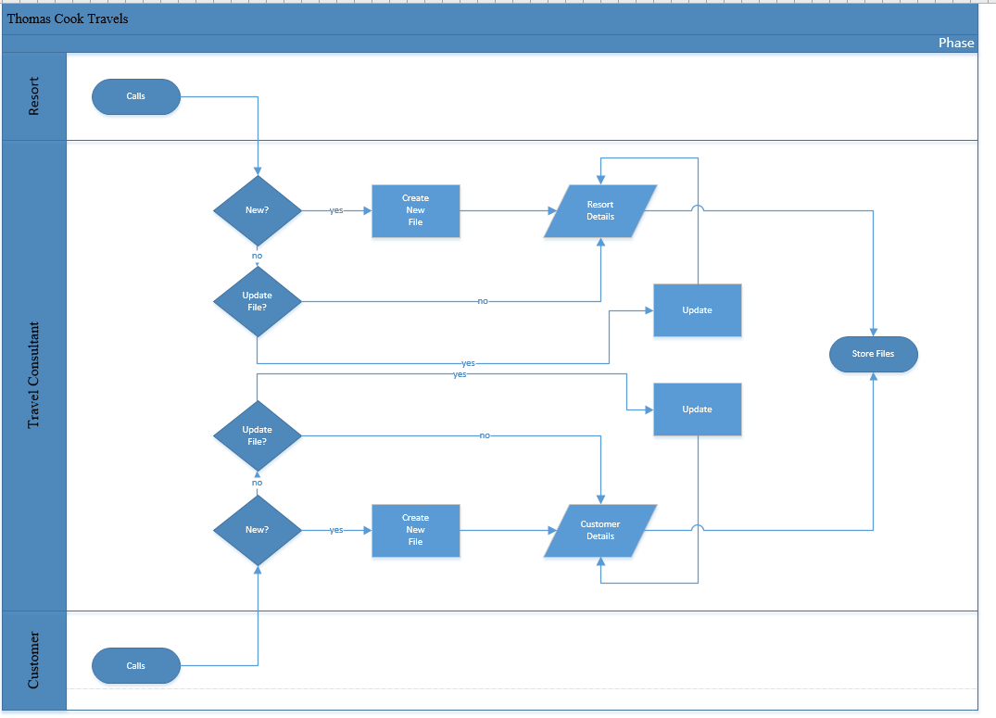

**entity relationship diagram**

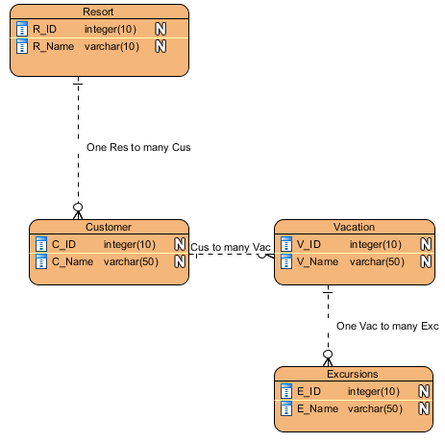

**functional hierarchy diagram**

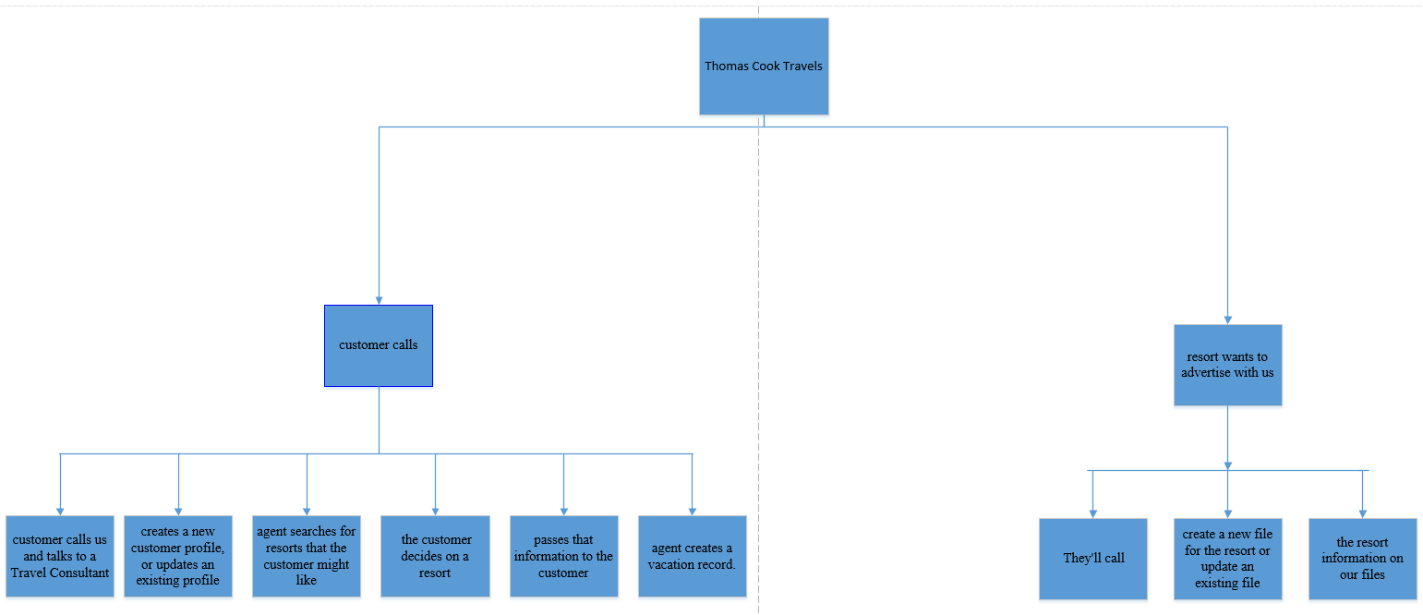

How well the modelling tools in Visio have been used to document the system requirements e.g. the clarity of the models, models appropriately named, symbols used correctly etc.

Good

A list of unresolved questions or problems that have come about from the analysis of the system’s requirements. If none were encountered, say so.

No budget